**NUTTY USER MANUAL**

**1. INTRODUCTION**

This manual includes instructions that explain the functionality of Nutty project; a food recipe community that offers users to share their recipes and give feedbacks on others. It also has recommendation algorithm that considers user preferences and similar user’s choices.

**2. LAUNCHING THE ANDROID APPLICATION**

To download the apk file of application you can click the following link or type it to address bar of your browser:

<http://titan.cmpe.boun.edu.tr:8080/nutty/>

**3. SIGN UP**

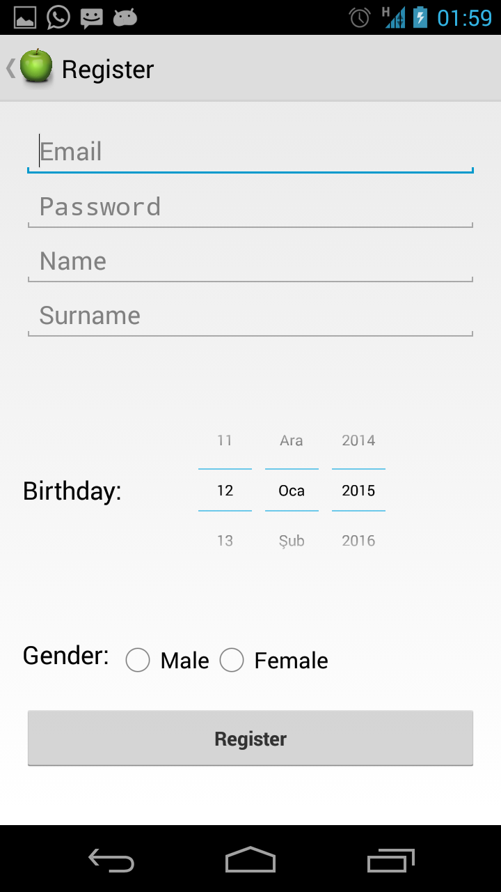

To use the system with full functionality you must register.

* Enter your name and surname.
* Write your e-mail address.
* Choose a password and write the same password to the field below to confirm it.
* Enter your birthday.
* Choose your gender.
* Click register button. You will be directed to your profile.

**4. LOGIN/LOGOUT**

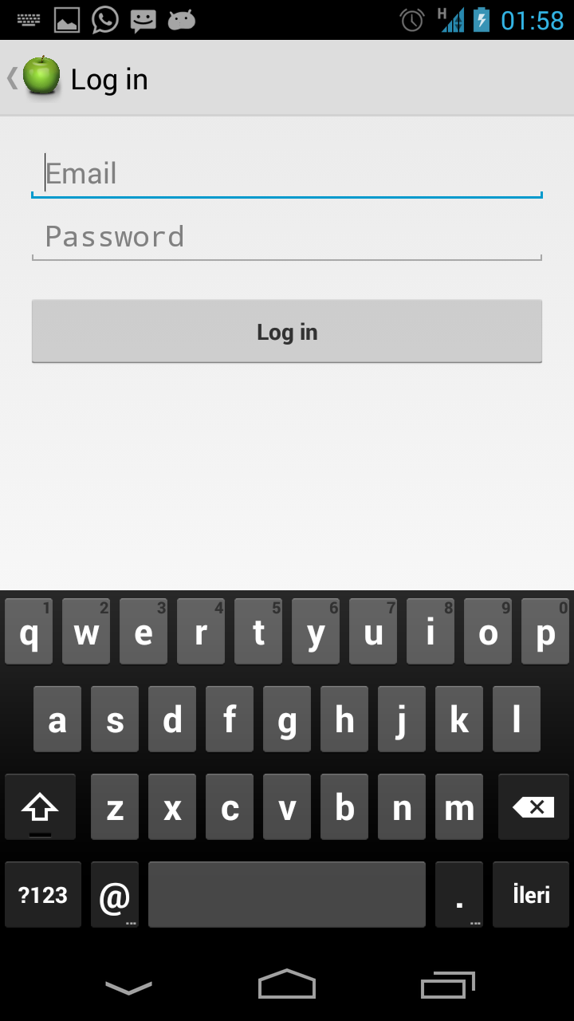

* Write your email and password that you registered with. Then click the “Login” button.
* You will be directed to your profile.

**Logout**

* You can logout by clicking the Logout button on the menu.

**5. BASIC SEARCH AND ADVANCED SEARCH**

**5.1 Basic Search**

* You can search for a recipe or a user on the search bar.
* Search function is available for guest users too. 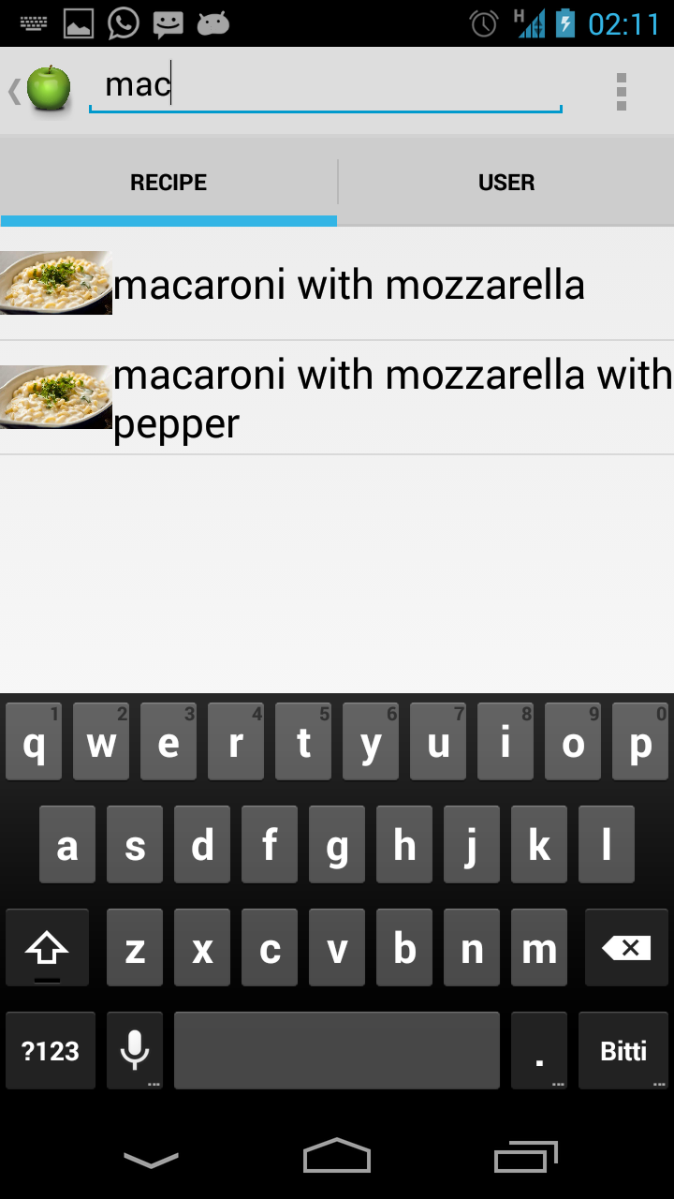
* Search results are listed as a list. (Derived recipes are also listed.)

**5.2 Advanced Search**

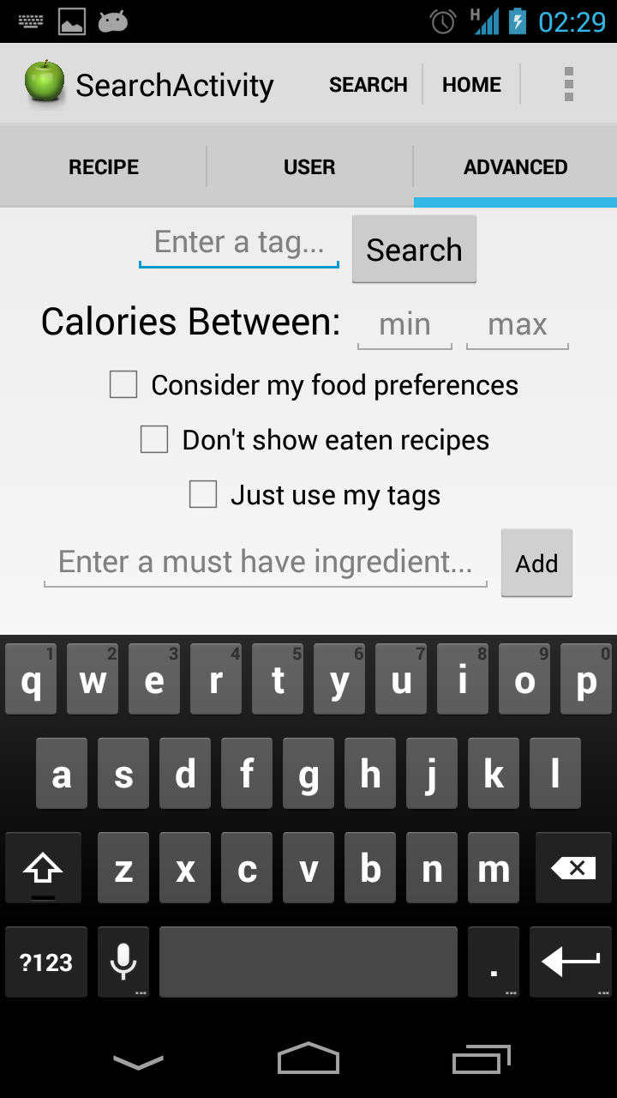

Advanced Search has an advanced recommendation algorithm that uses semantic tagging, consider your food preferences (intolerance, disease or simply non-preferred ingredients), ingredients and calorific values of the recipes.

Search results will be listed according to user preference (likes, health, cost, taste, ease or overall rates)

* Advanced Search function is available for registered users only.
* Semantic tagging is used in tag search. ( ie. if you search for “quick” tag, recipes with “fast” tag will be shown too. )
* You can search for a recipe:
* With tags (semantic)
* With a calorie limit (min-max)
* With must-have ingredients ( e.g recipes with beef and garlic)
* Advanced Search can consider your Food Preferences ( allergy or intolerance, entered in Options/Food Preferences) and hide the results with allergenic ingredients for you. (Consider my food preferences)

(For example, you have lactose intolerance, and stated your allergy in the “Food Preferences” part, if you choose “Consider my food preferences” option, recipes with milk, butter or cheese etc. will not be listed. )

* You can hide the recipes that you have already eaten on the results. (Don’t show eaten recipes)
* You can limit the results with the tags you entered. (i.e Don’t use semantic tagging). (Just use my tags option)

**6. ADD & DERIVE RECIPES**

**6.1 Add Recipes**

* Only registered users can add recipe.
* ‘Add Recipe’ function is reachable from navigation menu.
* A recipe includes
* Name of the recipe
* Its portion count
* The ingredients and their amounts (in grams, spoon or cup etc.)
* Tags (not mandatory)
* Upload the photo(s) of the recipe (not mandatory)
* And Directions.

*Add Recipe Page*

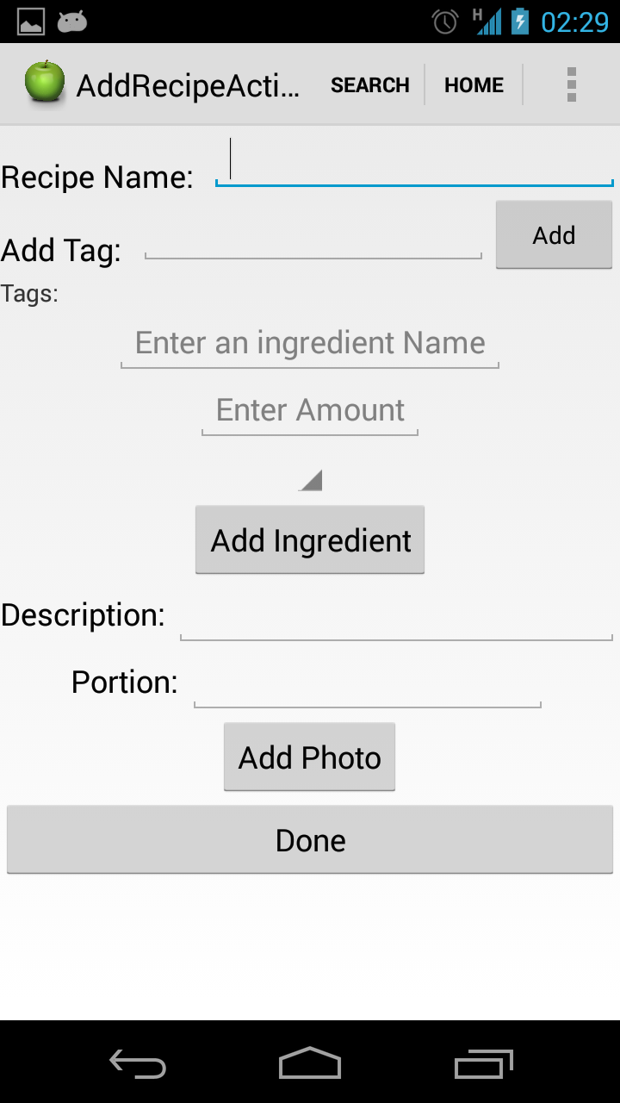

**6.2 Delete Recipe**

* You can delete your recipes with “Delete” button on the bottom of recipe page.

**6.3 Derive Recipe**

* Derive recipe function is available for registered users.
* You can derive new recipes from original recipes or derived versions using “Derive Recipe” button on the recipe page.
* On the relation tab, you can see its original version and also recipes derived from it.

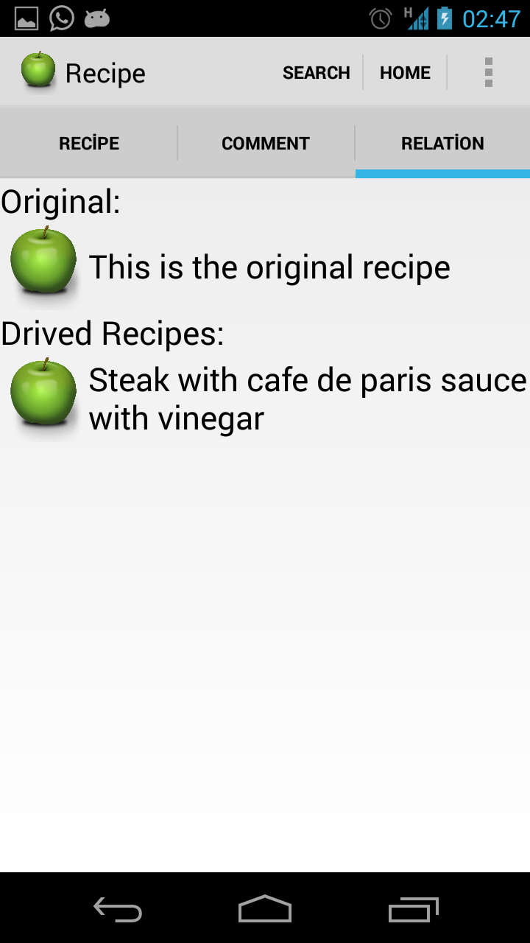

* Make changes on the original version and click on “D”one button. New derived version will be created.

**7. SOCIAL FEATURES**

* Registered users can give feedbacks to other users’ recipes, (eat, like, share, rate) and follow each other.

**7.1 Profile Page**

* Profile page is accessible from navigation menu.
* Every registered user has a profile page including:
* Name, surname
* Photo
* Badge Info (Gained from adding recipe etc.)
* Followings and followers’ counts
* User’s best recipes (according to user ratings)
* Recent Activities (like newsfeed, activities, likes, shares etc.)
* Shared Recipes (recipes that user “share”d)
* To edit your profile information go “User Settings” using via settings option on navigation bar.

**7.2 Newsfeed in Profile Page**

* There is a newsfeed section on the profile page including 3 tabs:
* Recent Activity: Your followers, users that you follow, recipes that you and users that you follow liked, rated, ate and shared.
* Shared Recipe: Recipes that you shared.
* Recently Eaten: Recipes that you marked as eaten.

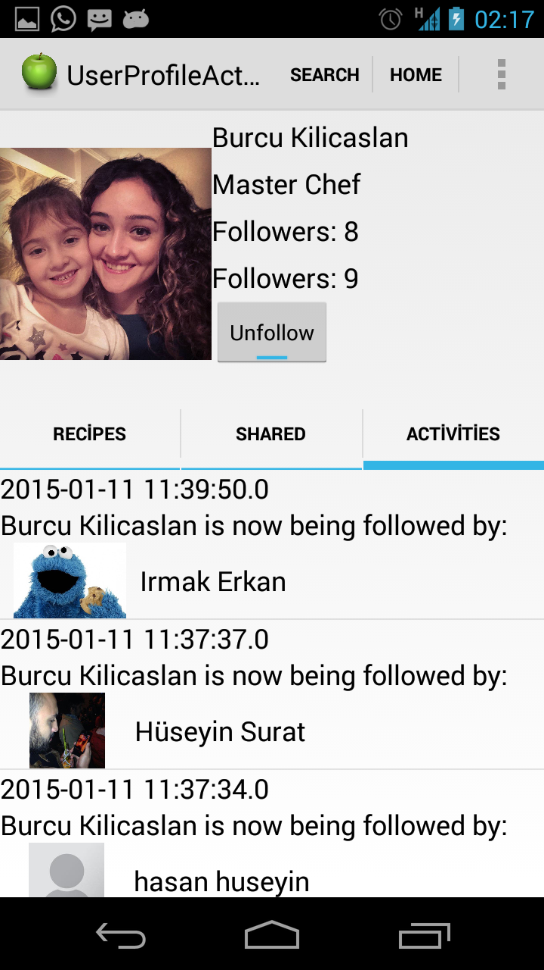

**7.3 Eat and Like Recipe**

* You can mark other users’ recipes as eaten using “Eat” button on the recipe page. This will show your rates’ quality and it is also used for hiding the eaten recipes on “Advanced Search” results.
* You can like other users’ recipes using “Like” button on the recipe page. This will affect recipe’s popularity and rank on “Advanced Search”.
* Your “Eat” and “Like” actions shown on your “Recent Activity” and “Recently Eaten” parts of your profile and also shown on your followers’ “Recent Activity” page.

*Recipe Page*

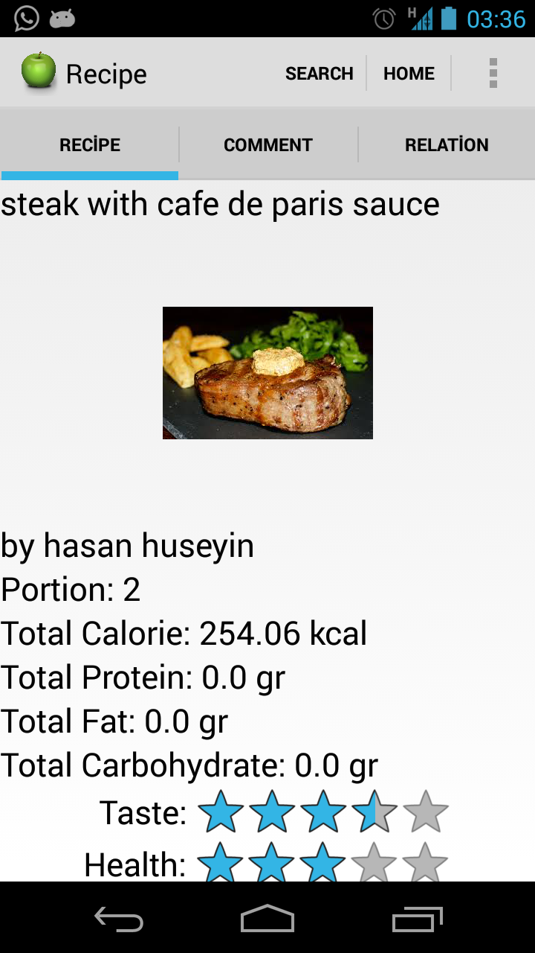

**7.4 Ratings**

* You can rate the recipes from 1 to 5 according to Health (1:Unhealthy-5:Healthy), Cost (1:Costy-5:Wallet Friendly), Taste (1:Tasteless-5:Yummy) and Ease ( 1: Difficult-5:Easy)
* Overall rating score of the recipe is average of all ratings.
* You can change your rating votes later if you want.

**7.6 Share Recipe**

* You can share a recipe with “Share” button on the recipe page.
* Shared recipes will published on your followers’ “Recent Activity” page and on your profile.

**7.7 Follow Users**

* You can “Follow” users using “Follow” button on their profile pages.
* A notification message is sent to users you want to follow and if they accept, their activities are shown on your “Recent Activity” section on profile page.
* You can accept your friends offer under settings page.

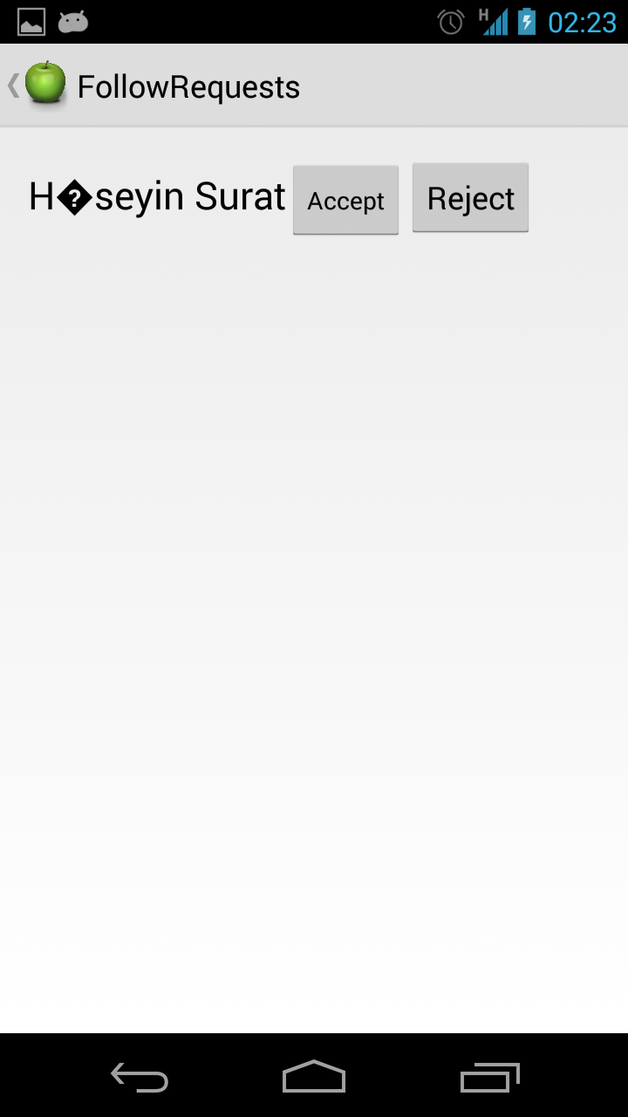

**8. SETTINGS**

* You can reach Setting Menu from the settings option on the navigation bar.

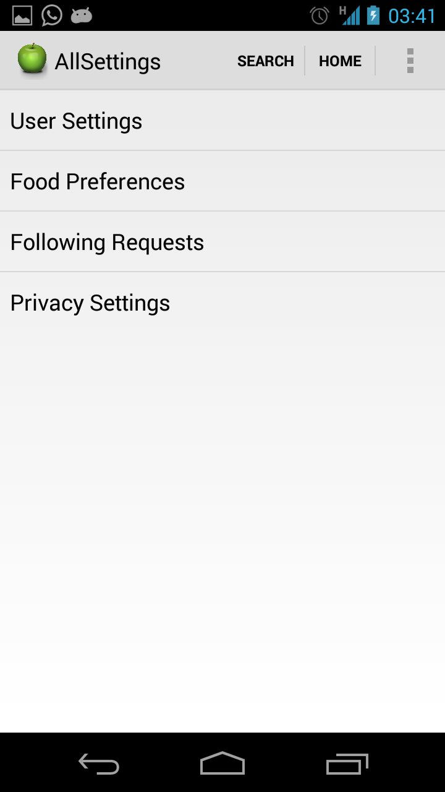

**8.1 Profile Settings**

* You can edit your profile information on this screen.

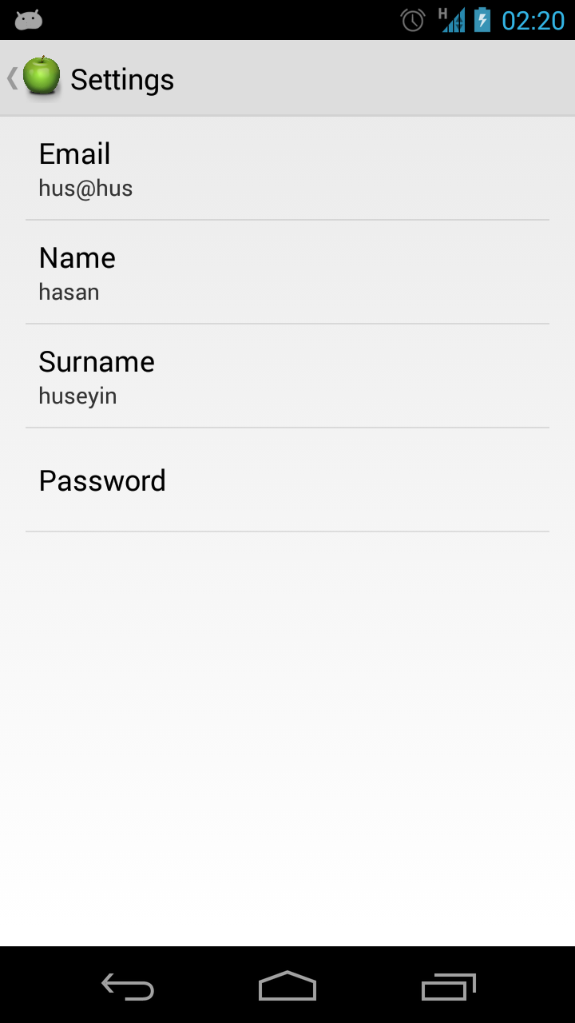

**8.2 Food Preferences**

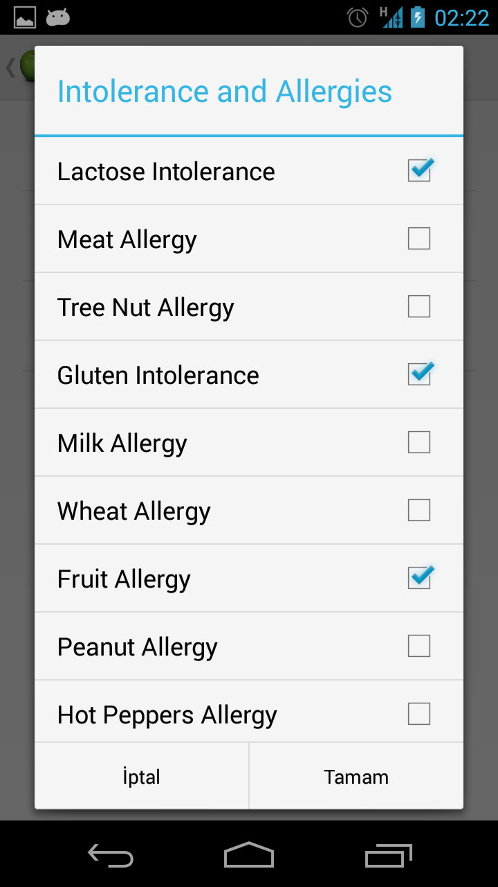

* You can state your food preferences from settings menu.
* Intolerance and Allergies:
* Diseases
* State your allergy and intolerances, so that advanced search can eliminate the results with ingredients that you should not eat, and show more relevant and safer recipes for you.
* You may choose to hide your Food Preferences from other users on Settings/Privacy Settings page.

**8.3 Privacy Settings**

* You can manage your privacy settings like:
* Being followable
* With request: In order someone to follow you, you should accept the follow request.
* Without request: Anyone can follow you without request.
* Health Conditions

Food Intolerances

Not Preferred Ingredients

Activities

* Hidden: Other users cannot see.
* Visible: Other users can see.

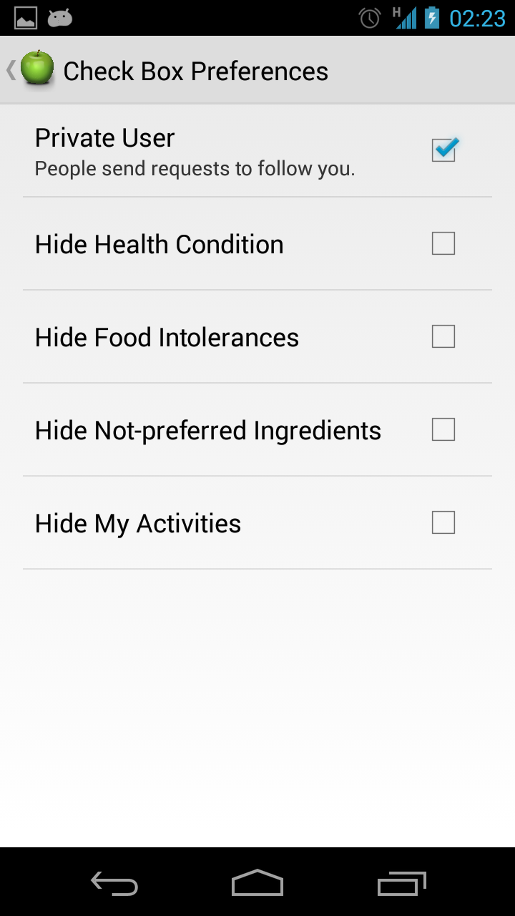

**9. RECOMMENDATIONS**

* You can see recommended recipes for you on the home (index) page.
* Recommendation algorithm works according to users with similar taste and results are shown as sorted according to relevance degrees.

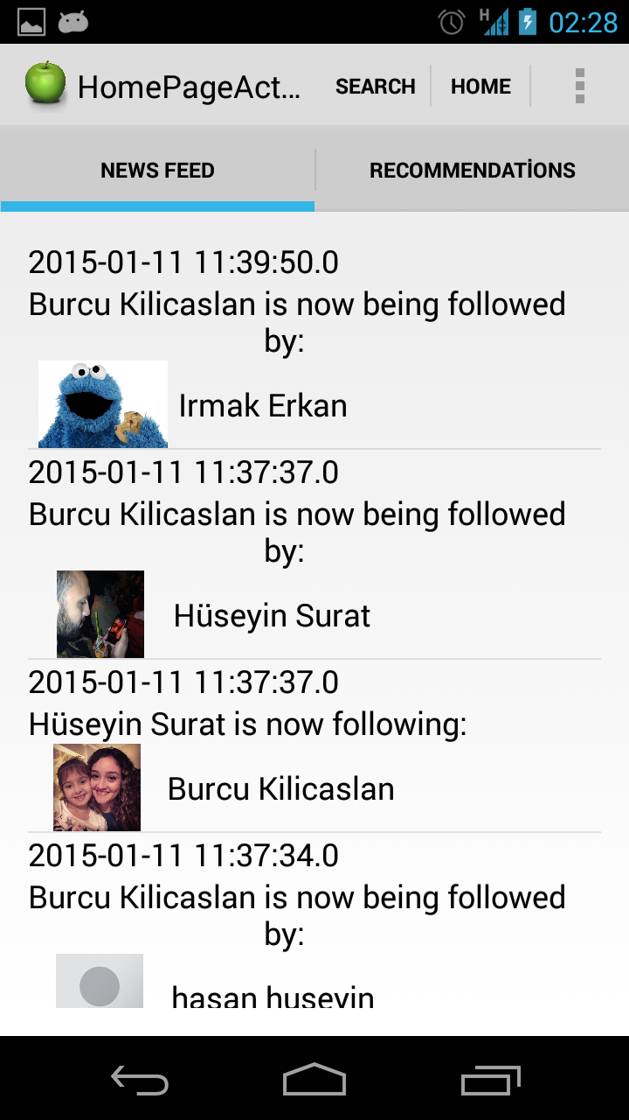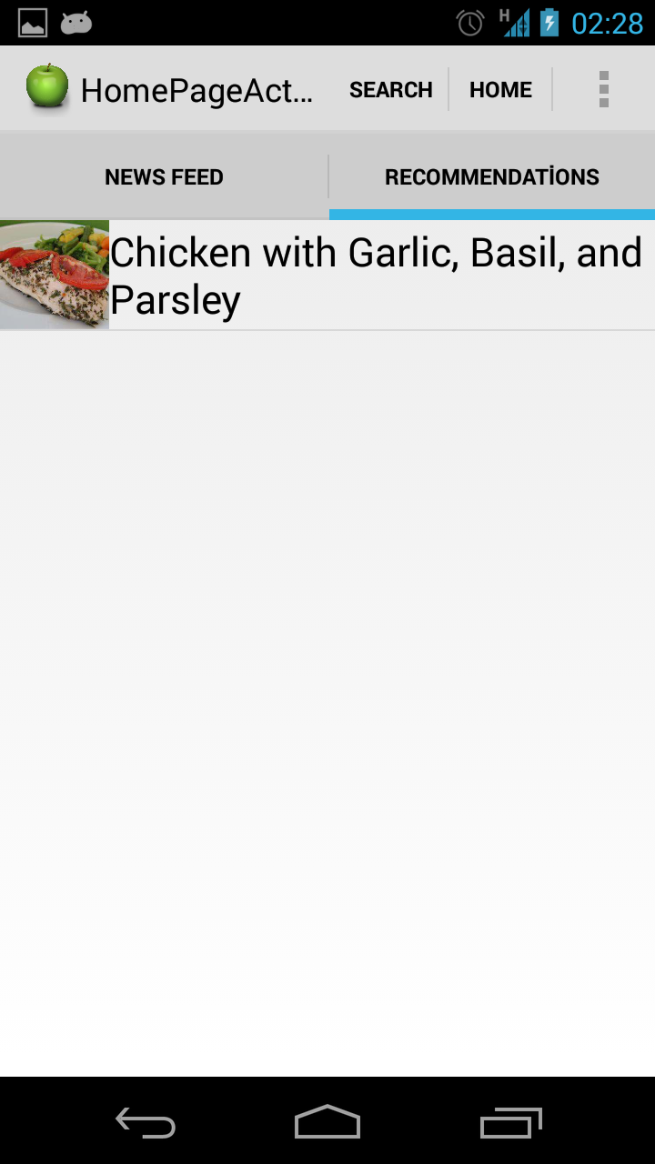

**10. GAMIFICATION**

* Users get points from their actions and gain chef degrees according to them.
* Here are the points for actions :
* Adding a recipe : 2 points
* Like : 2.5 points
* Eat : 2 points
* Rate : pointed for giving a rate 3 or more.
* Rate 3: 1.5 points
* Rate 4: 2 points
* Rate 5: 2.5 points
* Share : 2 points
* Comment : 1 points
* Here are the needed points for degrees :
* Beginner: 0 points
* Pre-chef: 1-4 points
* Chef: 5-19 points
* Master Chef: 20-49 points
* World Wide Chef: 50+